# Protein name - 1MMQ

#### MATRILYSIN COMPLEXED WITH HYDROXAMATE INHIBITOR

* **PDB DOI:**<https://doi.org/10.2210/pdb1MMQ/pdb>

Matrilysin, also known as Matrix Metalloproteinase-7 (MMP-7), is a zinc-dependent endopeptidase involved in various physiological processes like tissue remodeling, wound healing, and embryonic development. However, its dysregulation is linked to several pathological conditions, including cancer metastasis and inflammatory diseases.

Hydroxamate inhibitors are a class of compounds that effectively inhibit MMPs by chelating the active site zinc ion. This interaction prevents the enzyme from cleaving its target proteins, thus blocking its activity.

The complex of matrilysin with a hydroxamate inhibitor provides valuable insights into the mechanism of MMP inhibition. X-ray crystallography studies have revealed that the hydroxamate group of the inhibitor binds to the zinc ion, displacing the water molecule that is normally coordinated to the metal. This interaction results in the formation of a stable complex, preventing the enzyme from carrying out its proteolytic function.

Understanding the structure and mechanism of action of this complex has significant implications for the development of new therapeutic agents targeting MMPs. By designing more potent and selective inhibitors, researchers aim to develop drugs that can effectively treat diseases associated with MMP dysregulation while minimizing side effects.

**Matrilysin (MMP-7)**

* **Structure:** Matrilysin is a single-chain glycoprotein with a molecular weight of approximately 28 kDa. It consists of a catalytic domain, a hemopexin-like domain, and a propeptide domain.
* **Function:** Matrilysin plays a crumcial role in extracellular matrix remodeling by cleaving various proteins, including collagen, fibronectin, and laminin. It is involved in processes like wound healing, embryonic development, and tissue repair.
* **Dysregulation:** Overexpression of matrilysin has been linked to various diseases, including cancer metastasis, arthritis, and inflammatory bowel disease.

**Hydroxamate Inhibitors**

* **Mechanism of Action:** Hydroxamate inhibitors bind to the active site zinc ion of MMPs, forming a stable complex that prevents the enzyme from cleaving its target proteins.
* **Structure:** Hydroxamate inhibitors typically consist of a hydroxamic acid group (NH-OH-C=O) attached to a scaffold that interacts with the enzyme's binding site.
* **Examples:** Some well-known hydroxamate inhibitors include marimastat and prinomastat.

**Matrilysin-Hydroxamate Inhibitor Complex**

* **Structure:** The complex of matrilysin with a hydroxamate inhibitor has been studied extensively using X-ray crystallography. The hydroxamate group coordinates with the zinc ion in the active site, displacing the water molecule and forming a stable complex.
* **Mechanism of Inhibition:** The formation of the complex prevents the enzyme from cleaving its target proteins, thus inhibiting its activity.
* **Therapeutic Potential:** Understanding the structure and mechanism of action of this complex can aid in the development of more potent and selective MMP inhibitors for the treatment of diseases associated with MMP dysregulation.

**Ligands**

## . 1. 4-Piperidinone, 1-methyl-

1. **Chemical Formula:** C6H11NO
2. **Molecular Weight:** 113.1576 g/mol
3. **Appearance:** Colorless to pale yellow liquid
4. **Odor:** Amine-like odor
5. **Uses:**
   * Intermediate in the synthesis of various organic compounds, including pharmaceuticals and agrochemicals
   * Precursor for the synthesis of alkaloids and other heterocyclic compounds

## 2. Propanoic acid, 3-hydroxy-, methyl ester

1. **Chemical Formula:** C4H8O3
2. **Molecular Weight:** 104.11 g/mol
3. **Appearance:** Colorless liquid
4. **Odor:** Faintly sweet, fruity odor
5. **Uses:**
   * Intermediate in the synthesis of various organic compounds, including pharmaceuticals and agrochemicals
   * Flavoring agent in food and beverages

## 3. Methyl salicylate

1. **Chemical Formula:** C8H8O3
2. **Molecular Weight:** 152.15 g/mol
3. **Appearance:** Colorless to pale yellow liquid
4. **Odor:** Characteristic wintergreen odor
5. **Uses:**
   * Flavoring agent in food and beverages
   * Fragrance in perfumes and cosmetics
   * Topical analgesic and counterirritant

## 4. Diethyl Phthalate

1. **Chemical Formula:** C12H14O4
2. **Molecular Weight:** 222.23 g/mol
3. **Appearance:** Colorless liquid
4. **Odor:** Mild, pleasant odor
5. **Uses:**
   * Plasticizer in plastics and polymers
   * Solvent in perfumes and cosmetics
   * Insect repellent

**Molecular Docking**

Molecular docking is a computational method used to predict the preferred orientation of one molecule to a second when bound to each other to form a stable complex.

It is widely used in drug discovery to predict the binding affinities of small molecules (ligands) to target proteins.

**Preparation of Protein and Ligand Structures:**

**Protein Preparation**

* **Obtain the Protein Structure**
  + Download the protein structure from the Protein Data Bank (PDB).

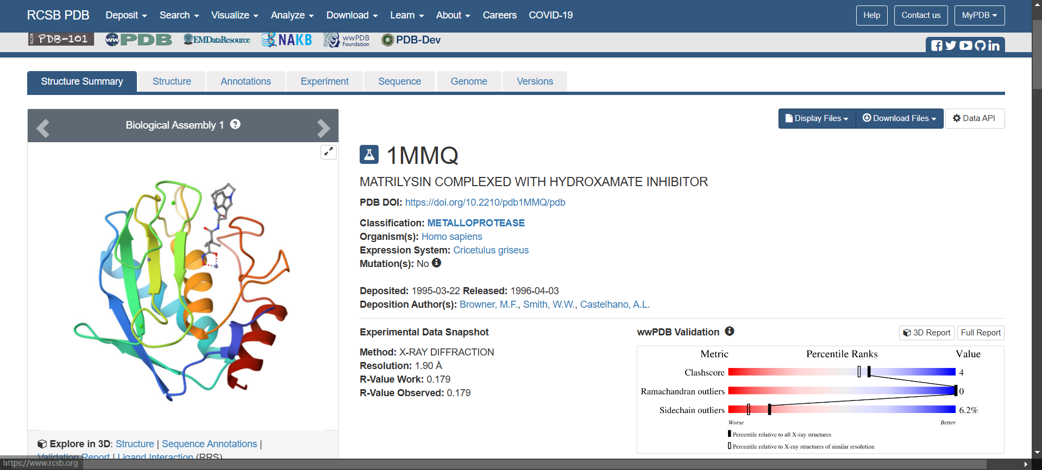

**Remove Water Molecules and Heteroatoms:**

* Use a tool like Discovery Studio to remove unnecessary water molecules and heteroatoms that are not involved in ligand binding.

Before removing the molecules

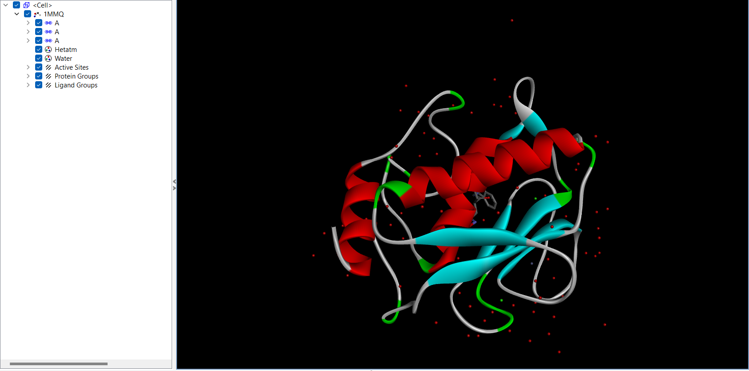

After removing the molecules

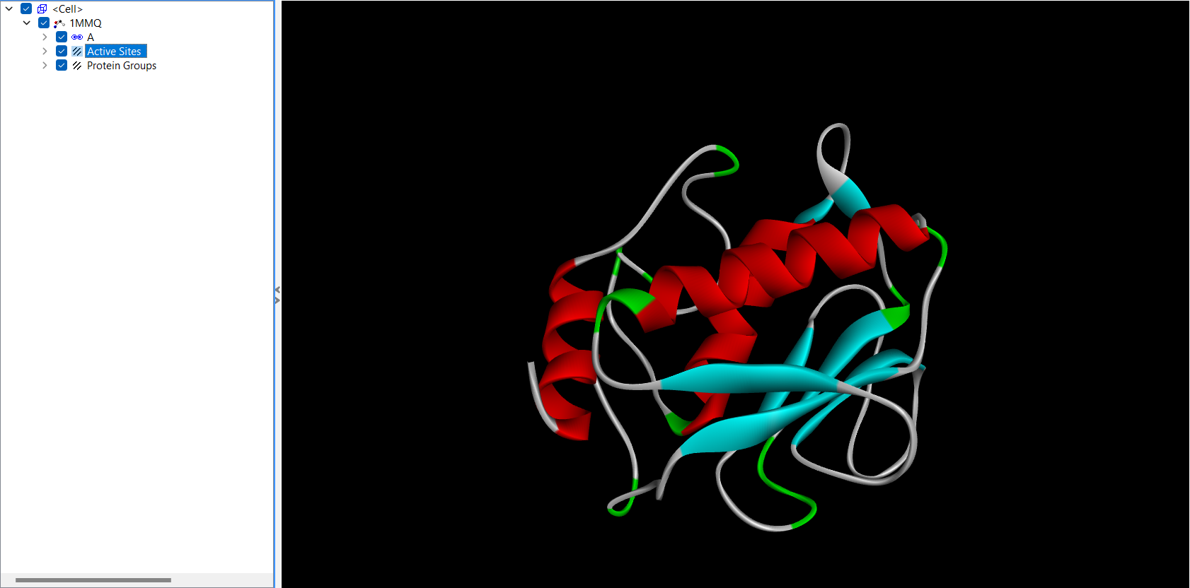

**Ligand Preparation:**

* **Obtain the Ligand Structure:**
  + Download the ligand structure from a database like PubChem or draw it using a chemical drawing tool.

• **Minimize Energy:**

* Minimize the energy of the ligand using a force field-based minimization method to remove any steric clashes.

• **Generate Different Conformers:**

* Generate different conformers of the ligand to explore various binding orientations.

**Assign Partial Charges:**

* Assign partial charges to the ligand atoms using a suitable force field.

PyRx

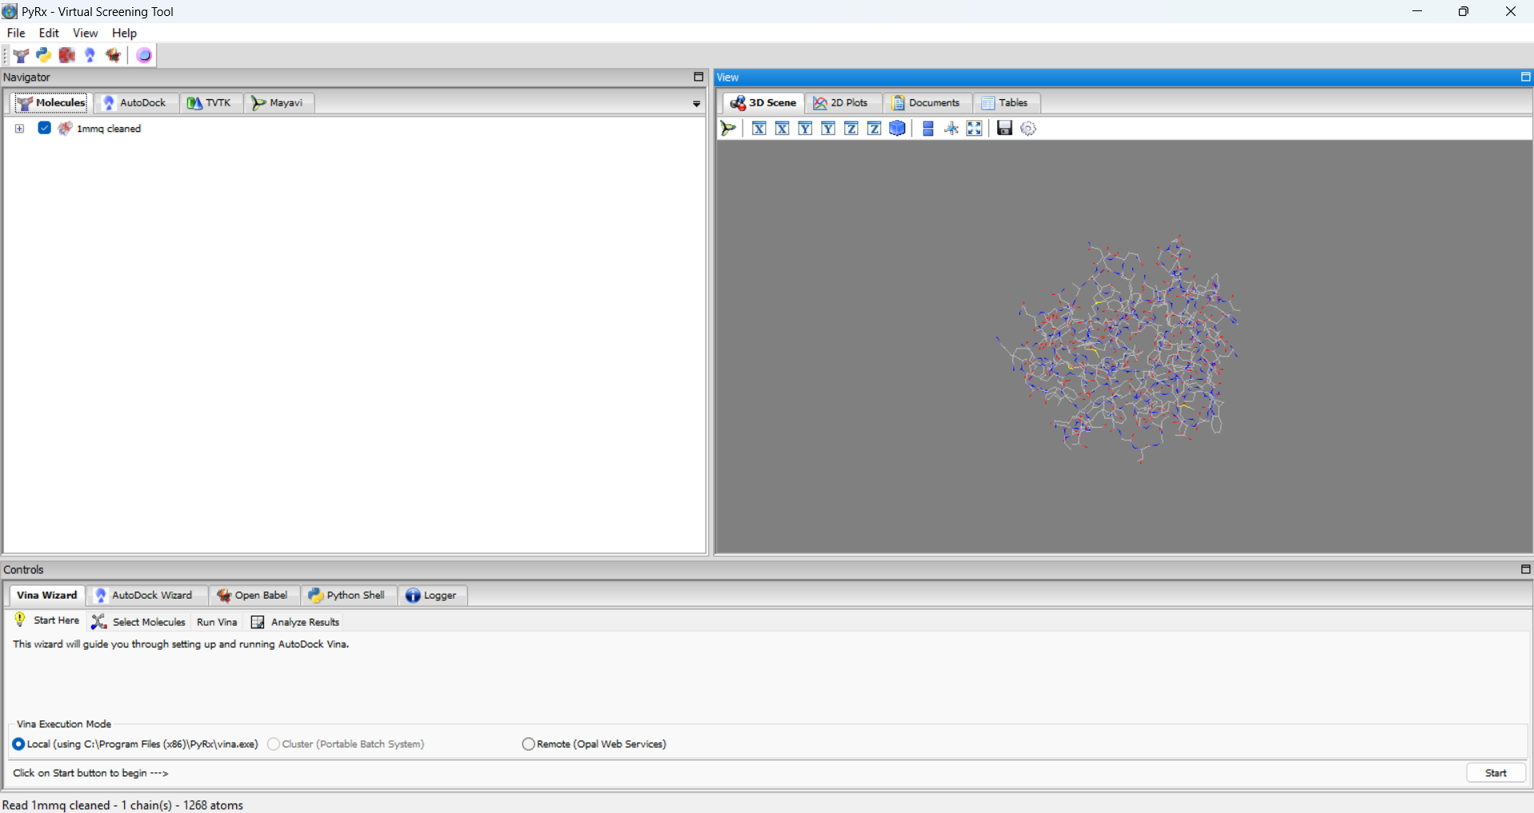

After loading 1st ligand

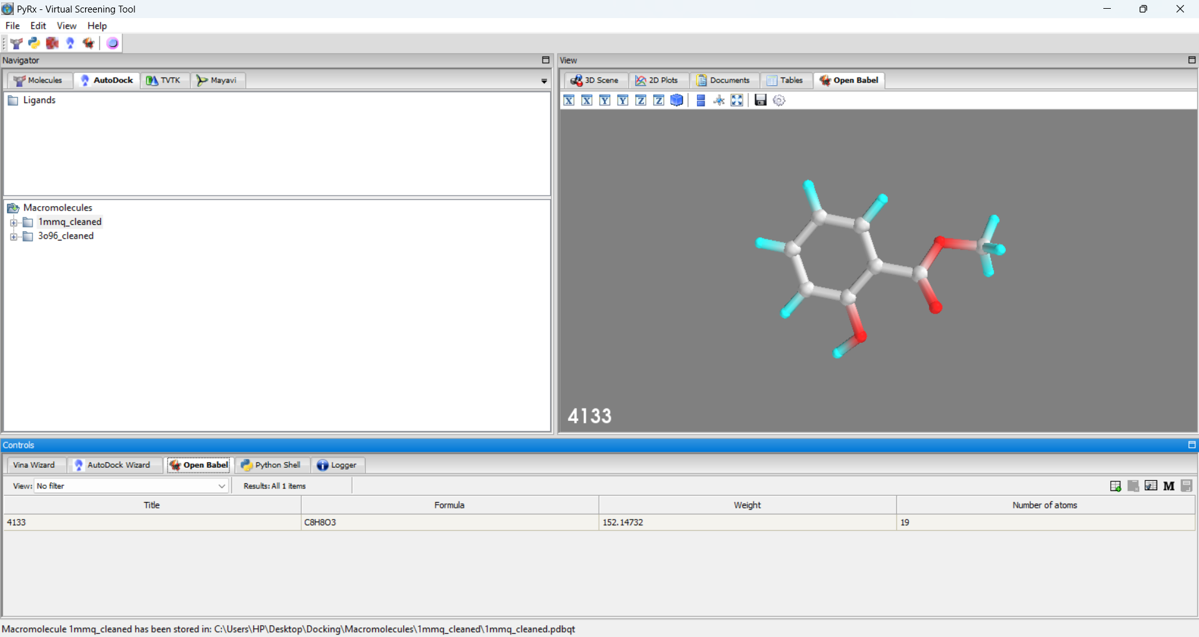

After loading 2nd ligand

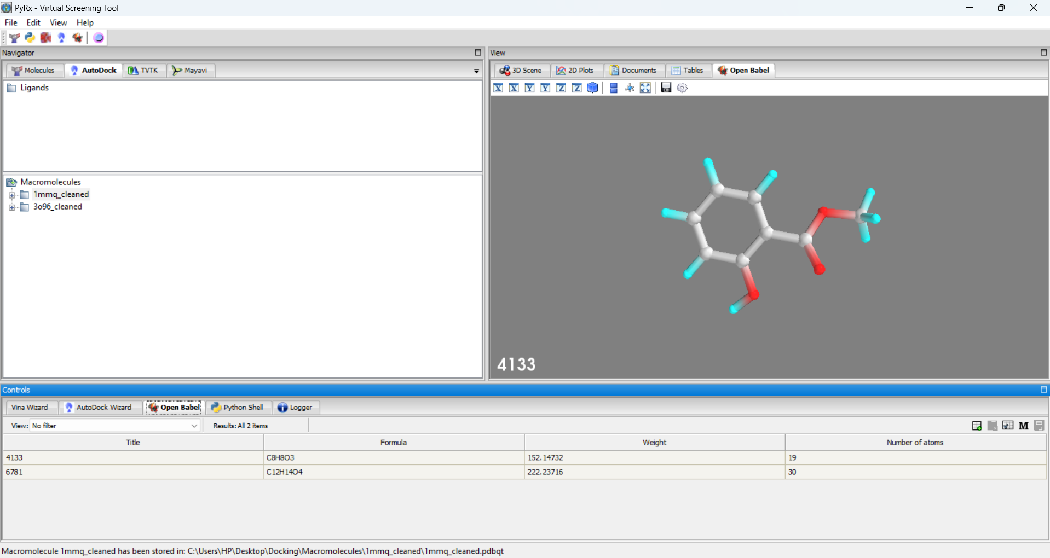

After loading 3rd molecule

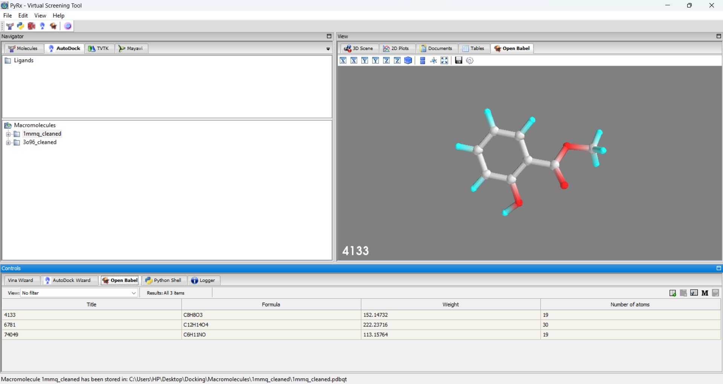

After loading the 4th ligand

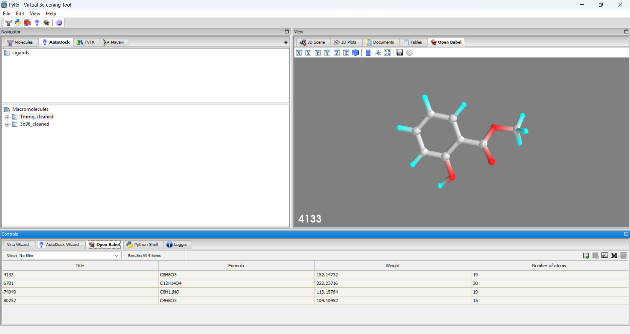

After minimizing the energy of all ligands

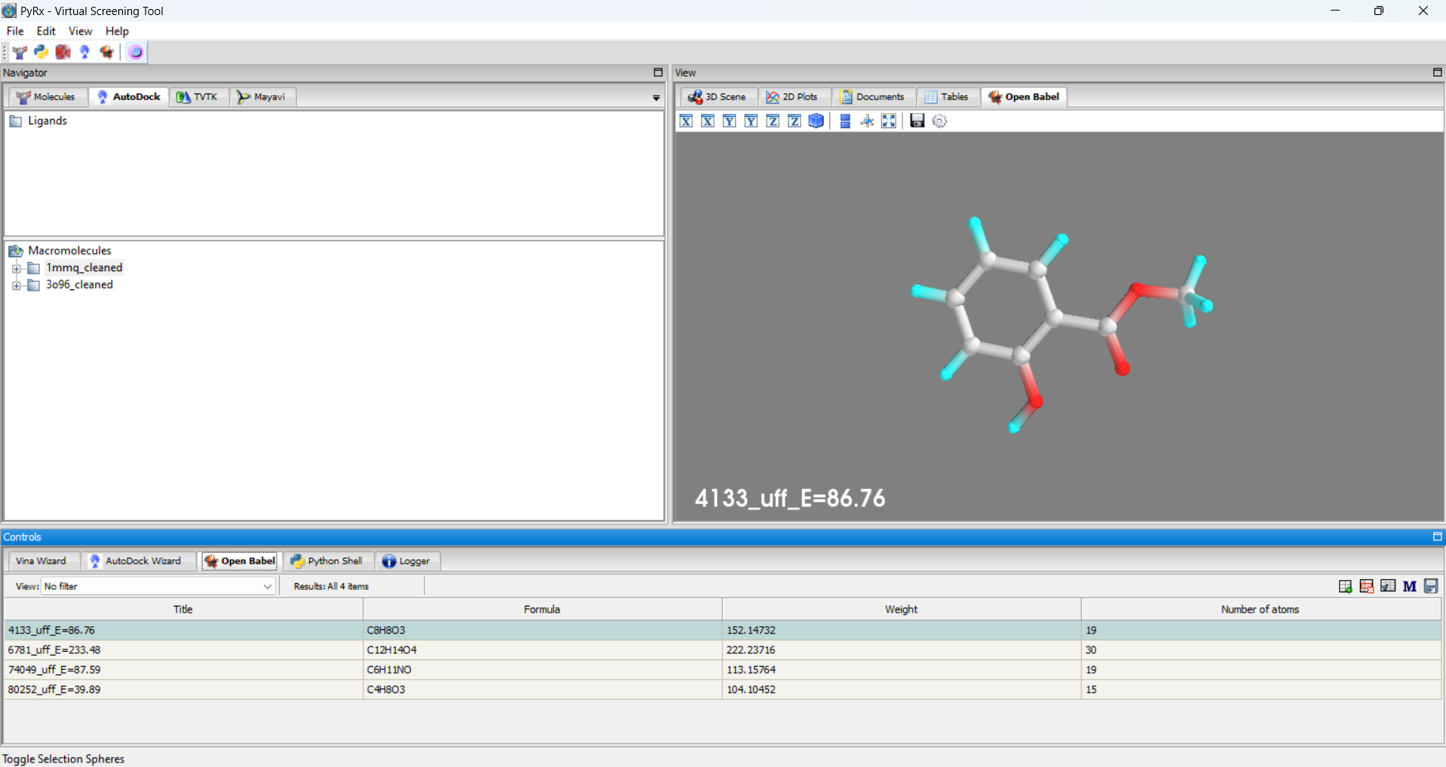

**2. Molecular Docking:**

**Using PyRx:**

* **Prepare the Receptor and Ligand:**
  + Convert the protein and ligand structures to PDBQT format, which is required by AutoDock Vina, the docking engine used by PyRx.
* **Define the Search Space:**
  + Define a grid box around the binding site of the protein to specify the region where the ligand can explore.

Converting all to autodock ligand(pdbqt)

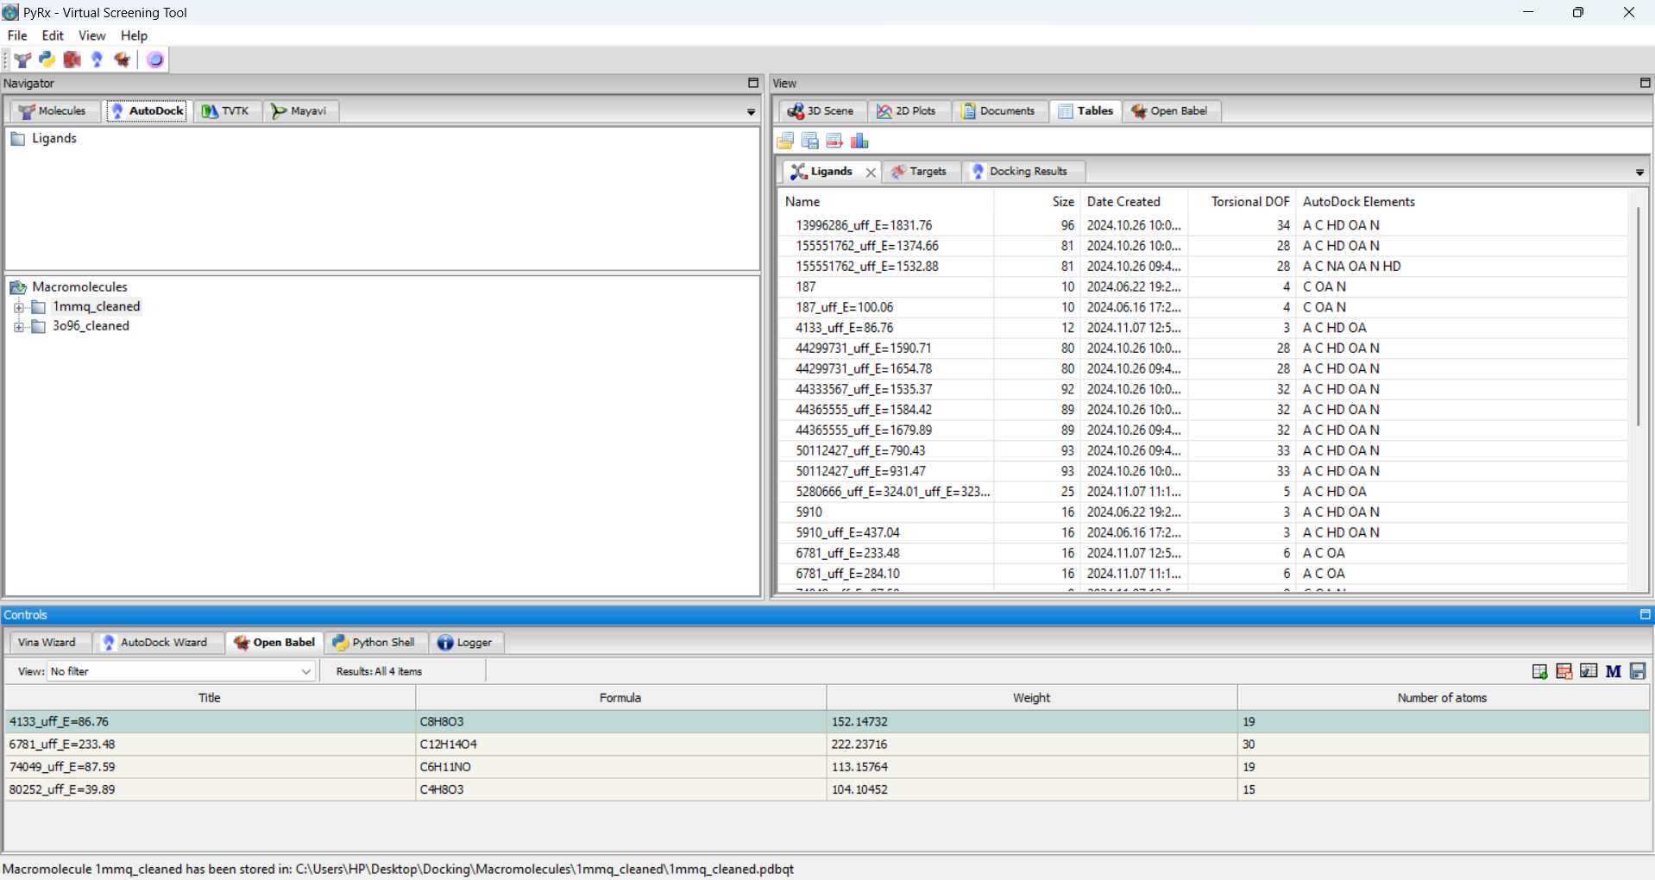

Vina wizard

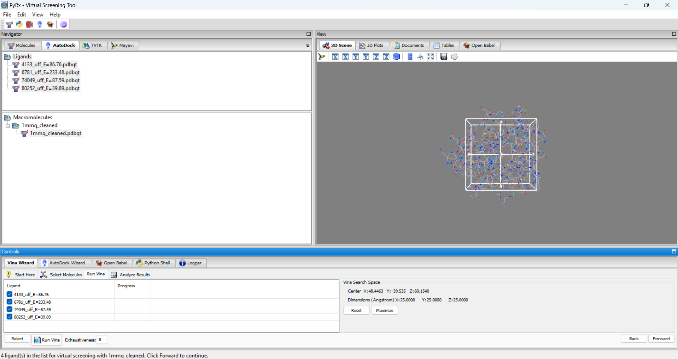

* **Run Docking:**
  + Launch the AutoDock Vina docking job within PyRx, specifying the receptor, ligand, and grid box parameters.
* **Analyze Results:**
  + PyRx will generate a number of docked poses for each ligand, ranked by their binding affinity scores.

After fitting in the box

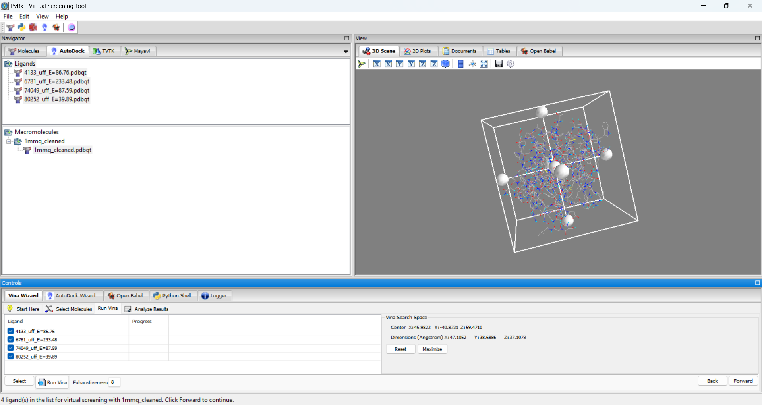

Csv docked file



Link to the file – <https://drive.google.com/file/d/1tzA_WzGXqU3GpJNSPB3lUqDgxkmDOCkP/view?usp=sharing>



After downloading in pdb format

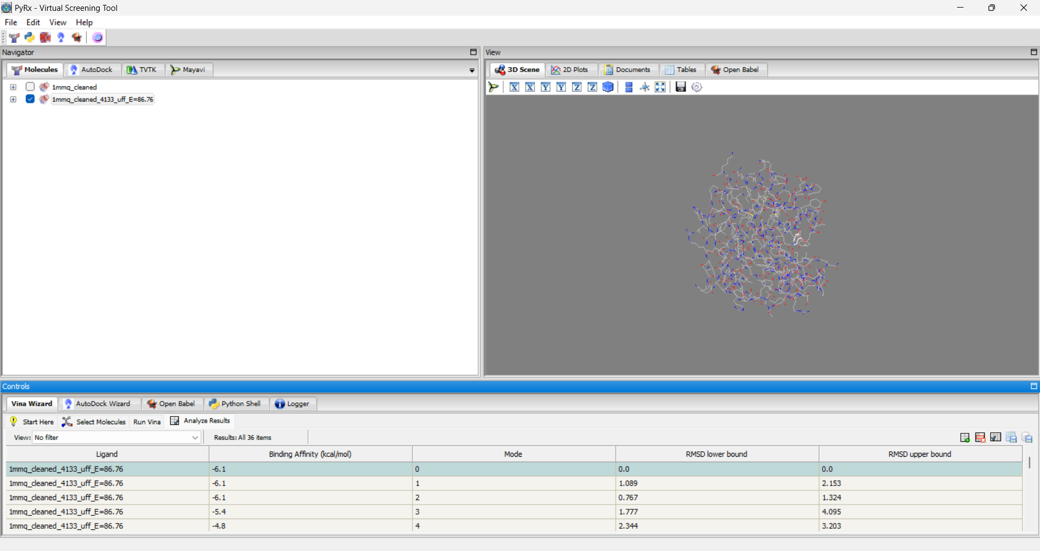

**Visualization and Analysis:**

**Using PyMOL:**

* **Load the Docked Complex:**
  + Load the docked complex (protein-ligand complex) into PyMOL.
* **Visualize the Binding Interactions:**
  + Use PyMOL's visualization tools to explore the interactions between the ligand and the protein, such as hydrogen bonds, hydrophobic interactions, and electrostatic interactions.
* **Create Figures:**
  + Generate high-quality figures to illustrate the binding mode and interactions.

Pymol

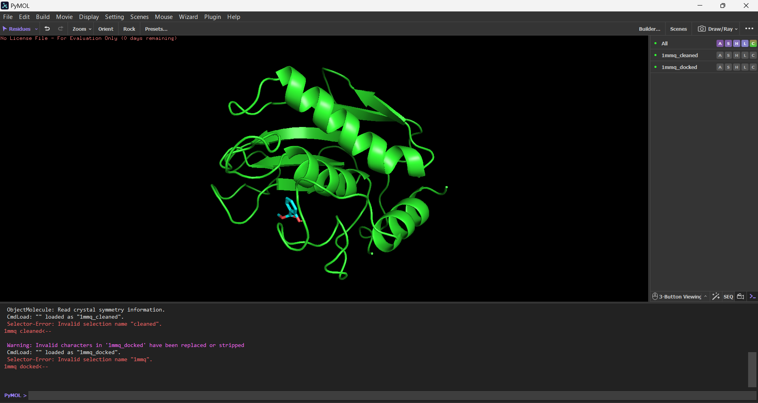

Active ligand

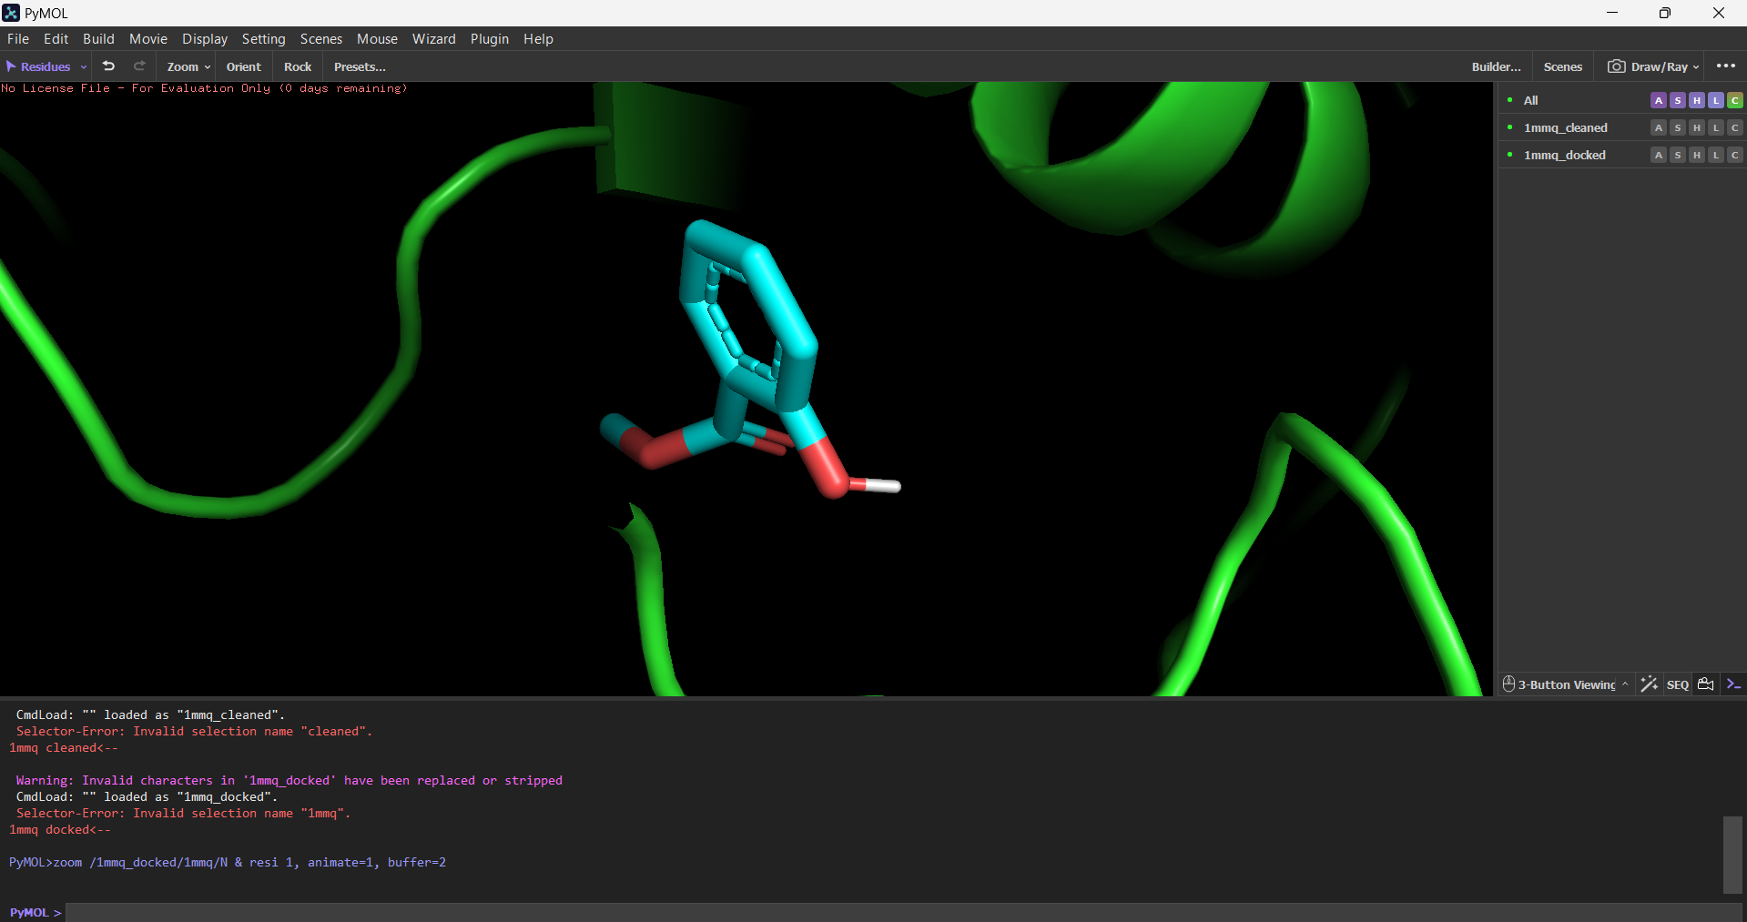

Biovia 2d structure

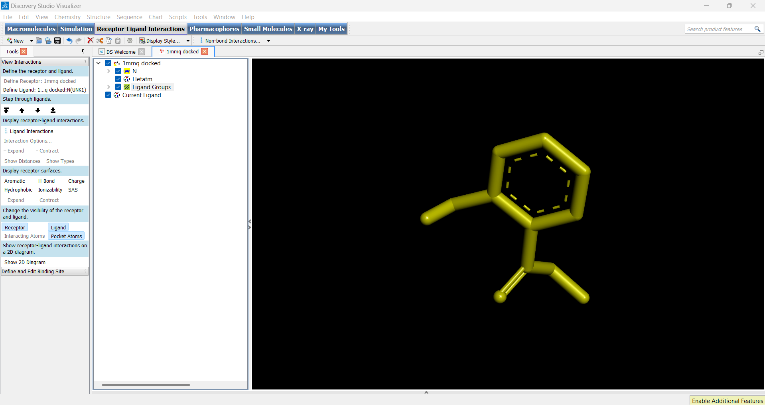

Ligplot

**Using LigPlot:**

* **Prepare the Docked Complex:**
  + Prepare the docked complex in PDB format.
* **Run LigPlot:**
  + Run LigPlot to generate a 2D diagram of the ligand-protein interactions.
* **Analyze the Interactions:**
  + LigPlot will highlight hydrogen bonds, hydrophobic interactions, and other key interactions.

• **Validation:**

* Validate the docking results using experimental data, such as binding affinities or crystal structures.

• **Virtual Screening:**

* Use docking to screen large libraries of compounds to identify potential drug candidates.

• **Optimization:**

* Refine the docked poses using molecular dynamics simulations or quantum mechanical calculations.

